Create a test case for the scenario below:

We require a bot to login to Gmail and retrieve all emails with the subject of “Neostella.” Emails in the inbox that do not match this criteria should be marked as read and moved to the Exceptions folder. Those with the correct heading should be marked as unread, moved to the processing folder. The bot should then scan the processing folder emails (whilst ensuring they are marked as unread when completed) and save any attachments to a folder on a shared network drive with today's date. Once the inbox is empty the bot should exit out of all applications and email [Processed@neostella.com](mailto:Processed@neostella.com).

Test case by Juan Camilo Arcila N.:

**Test Case description:** Verify Gmail Bot Processing of "Neostella" Emails According to Business Rules

**Preconditions:**

1. A valid Gmail account with credentials available to the bot.
2. The Gmail account contains emails with the subject "Neostella" including attachments and other emails without any attachment.
3. The Gmail account contains emails without “Neostella” subject
4. "Exceptions" and "Processing" folders exist within the Gmail account.
5. A network shared Drive folder is accessible with write permissions.
6. The bot is configured to access the specified Gmail account and network shared drive.

**Test Steps:**

1. Start the bot and verify that it successfully logs into the Gmail account.
2. The bot should access the inbox and begin to scan for emails.
3. The bot should identify all emails with the subject "Neostella." These emails should be moved from the inbox to the "Processing" folder.
4. The bot should identify all emails that do not have the subject "Neostella." These emails should be moved from the inbox to the "Exceptions" folder.
   * Verify that the emails in the "Exceptions" folder are marked as read.
   * Verify that the emails in the "Processing" folder are marked as unread.
5. Confirm that the inbox is now empty.
6. The bot should open the "Processing" folder, iterate through each email, and click in the attachment option to share it in a drive folder.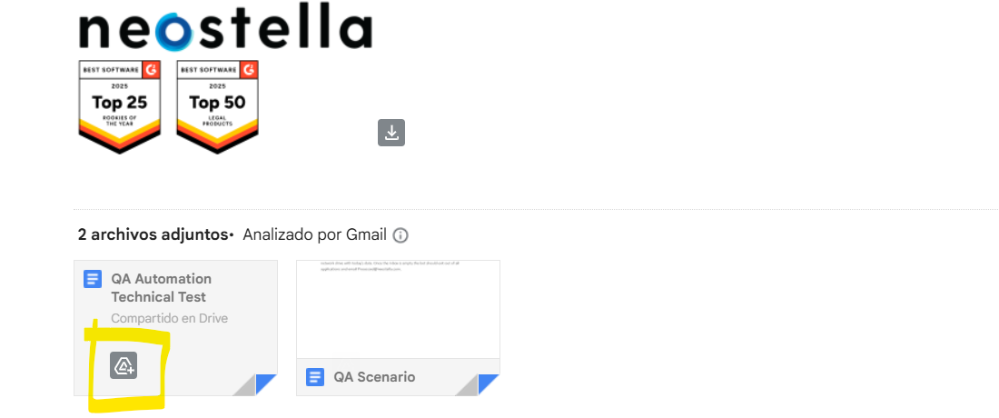

Image included as reference for Google option to share the attachment in a drive folder

1. Verify that the attachments are saved to the specified shared network drive in a new folder named with today's date.
2. Verify that after processing the attachments, the emails in the "Processing" folder should remain marked as unread.
3. The bot should then close all open applications, including the web browser or any Gmail client it was using.
4. Confirm that an email notification is sent to “Processed@neostella.com” upon completion.

**Expected Results:**

* Bot successfully logs in and accesses the Gmail inbox.
* All emails with the subject "Neostella" are moved to the "Processing" folder and are unread.
* All other emails are moved to the "Exceptions" folder and are read.
* The inbox is empty after the move operations.
* Attachments from emails in the "Processing" folder are saved to a folder named with the current date on the shared network drive.
* Emails in the "Processing" folder remain unread after their attachments are saved.
* The bot successfully exits all applications.
* An email is sent to Processed@neostella.com.